**WorldSkills Singapore**

**Qualifying Round**

**Test Project**

**(Temasek Polytechnic)**

**IT Software Solutions for Business**

**Style Guide**

WSS2020_QR_TP_StyleGuide

Written by:

WorldSkills Singapore Expert

(Temasek Polytechnic)

# ASEAN Skills 2020 - Style Guide

## Overview

This style guide defines the visual identity for ASEAN Skills 2020. Any applications/programs, documents, training materials, etc. must follow this guide. This guide is meant to ensure the consistency and quality of everything developed for ASEAN Skills 2020. It covers professionalism, colours, logo, fonts, etc.

## Professionalism

To make sure that ASEAN Skills 2020 is respected as a professional event, follow these rules. All the screens of the apps developed for ASEAN Skills 2020 must follow this style guide. The logo must be included on all screens of every app for consistent branding of the app. Ensure that all interfaces, documents, etc. are clean, consistent, visually-appealing and free of errors. They must be easy to read and easy to understand. Use good alignment and appropriate whitespace. Group relevant user interface elements together logically as needed to make the system easy to use. Use labels and help messages, where appropriate, to guide users through the system.

## The Logo

The logo was designed with three main colours in mind. The basic rules of using the logo are as follows:

### Exclusion Zone

To protect the clarity and integrity of the logo, it has an exclusion zone, which is a clearance or area of clear space around it. As marked below by grey boxes, the proposed area is 15% of the height and width of the logo from each side. This improves clarity, retains identity and ensures consistency.

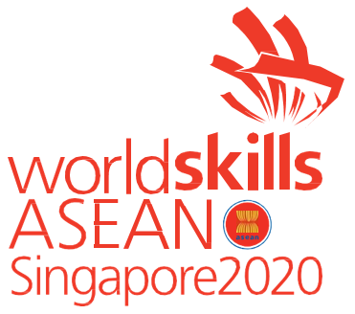

### Variations

The following variations of the logo are provided. Competitors can resize the logo as appropriate, maintaining the size ratio and exclusion. The monochrome is also provided in both white (to be used on dark backgrounds) and black (to be used in light backgrounds). All the images are transparent where applicable.

### Misuse

|  |  |
| --- | --- |
| **Stretch:**  You must not stretch, skew or rotate the logo for use in your work |  |
|  |  |
| **Colour:**  You may not change the colour palette, hue, or  saturation used in the logo to match your work |  |
|  |  |
| **Background:**  Never place the logo over a photo, textures, or coloured background where there will not be sufficient amount of  contrast to make it legible | Image result for worldskills asean 2020 png" |
|  |  |
| **Remastering:**  You may not re-create the logo in any form or shape either by removing or moving around components  of the logo |  |

## Colour Palette

The following are the recommended colour palettes to be used in the applications.

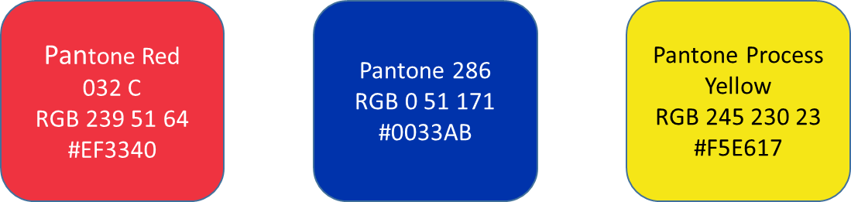

## Fonts

Here are the recommended fonts to be used in designing the user interfaces for all applications. The secondary font should only be used if the primary font is not available.

### PRIMARY FONT

Helvetica Normal

|  |  |  |  |  |  |  |  |  |  |  |  |  |
| --- | --- | --- | --- | --- | --- | --- | --- | --- | --- | --- | --- | --- |
| a | b | c | d | e | f | g | h | i | j | K | l | m |
| n | o | p | q | r | s | t | u | v | w | X | y | z |
| A | B | C | D | E | F | G | H | I | J | K | L | M |
| N | O | P | Q | R | S | T | U | V | W | X | Y | Z |

**Helvetica Bold**

|  |  |  |  |  |  |  |  |  |  |  |  |  |
| --- | --- | --- | --- | --- | --- | --- | --- | --- | --- | --- | --- | --- |
| **a** | **b** | **c** | **d** | **e** | **f** | **g** | **h** | **i** | **j** | **K** | **l** | **m** |
| **n** | **o** | **p** | **q** | **r** | **s** | **t** | **u** | **v** | **w** | **X** | **y** | **z** |
| **A** | **B** | **C** | **D** | **E** | **F** | **G** | **H** | **I** | **J** | **K** | **L** | **M** |
| **N** | **O** | **P** | **Q** | **R** | **S** | **T** | **U** | **V** | **W** | **X** | **Y** | **Z** |

### TITLE FONT

Myriad Pro

|  |  |  |  |  |  |  |  |  |  |  |  |  |
| --- | --- | --- | --- | --- | --- | --- | --- | --- | --- | --- | --- | --- |
|  |  |  |  |  |  |  |  |  |  |  |  |  |
|  |  |  |  |  |  |  |  |  |  |  |  |  |
|  |  |  |  |  |  |  |  |  |  |  |  |  |
|  |  |  |  |  |  |  |  |  |  |  |  |  |

**Myriad Pro Bold**

|  |  |  |  |  |  |  |  |  |  |  |  |  |
| --- | --- | --- | --- | --- | --- | --- | --- | --- | --- | --- | --- | --- |
|  |  |  |  |  |  |  |  |  |  |  |  |  |
|  |  |  |  |  |  |  |  |  |  |  |  |  |
|  |  |  |  |  |  |  |  |  |  |  |  |  |
|  |  |  |  |  |  |  |  |  |  |  |  |  |

### SECONDARY FONT

Verdana Regular (Verdana)

|  |  |  |  |  |  |  |  |  |  |  |  |  |
| --- | --- | --- | --- | --- | --- | --- | --- | --- | --- | --- | --- | --- |
| a | b | c | d | e | f | g | h | i | j | K | l | m |
| n | o | p | q | r | s | t | u | v | w | X | y | z |
| A | B | C | D | E | F | G | H | I | J | K | L | M |
| N | O | P | Q | R | S | T | U | V | W | X | Y | Z |

**Verdana Bold (Verdana Bold)**

|  |  |  |  |  |  |  |  |  |  |  |  |  |
| --- | --- | --- | --- | --- | --- | --- | --- | --- | --- | --- | --- | --- |
| **a** | **b** | **c** | **d** | **e** | **f** | **g** | **h** | **i** | **j** | **K** | **l** | **m** |
| **n** | **o** | **p** | **q** | **r** | **s** | **t** | **u** | **v** | **w** | **X** | **y** | **z** |
| **A** | **B** | **C** | **D** | **E** | **F** | **G** | **H** | **I** | **J** | **K** | **L** | **M** |
| **N** | **O** | **P** | **Q** | **R** | **S** | **T** | **U** | **V** | **W** | **X** | **Y** | **Z** |